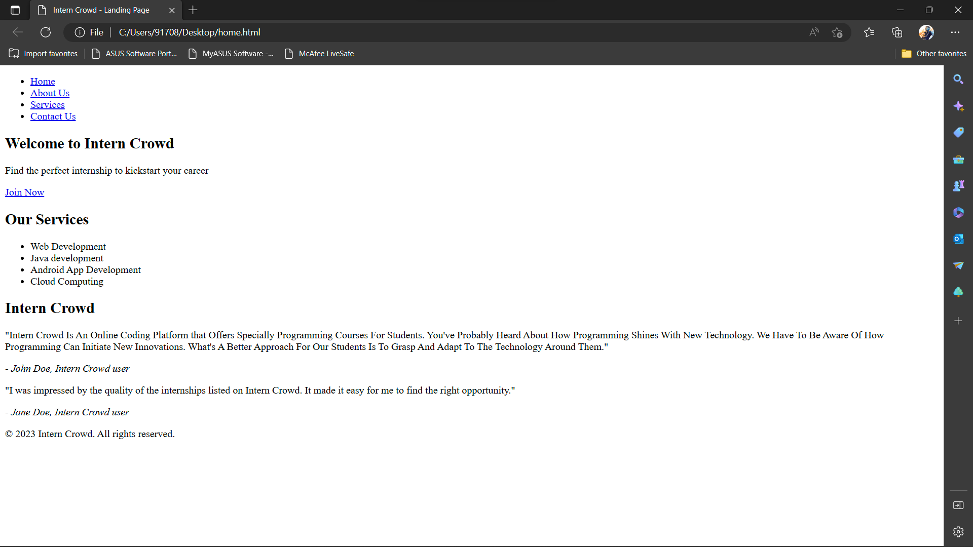

<!DOCTYPE html>

<html>

<head>

<title>Intern Crowd - Landing Page</title>

<link rel="stylesheet" href="style.css">

</head>

<body>

<header>

<nav>

<ul>

<li><a href="#">Home</a></li>

<li><a href="#">About Us</a></li>

<li><a href="#">Services</a></li>

<li><a href="#">Contact Us</a></li>

</ul>

</nav>

</header>

<main>

<section class="hero">

<h1>Welcome to Intern Crowd</h1>

<p>Find the perfect internship to kickstart your career</p>

<a href="#" class="cta">Join Now</a>

</section>

<section class="features">

<h2>Our Services</h2>

<ul>

<li>Web Development </li>

<li>Java development </li>

<li>Android App Development</li>

<li>Cloud Computing</li>

</ul>

</section>

<section class="testimonials">

<h2>Intern Crowd </h2>

<div class="testimonial">

<p>"Intern Crowd Is An Online Coding Platform that Offers Specially Programming Courses For Students. You've Probably Heard About How Programming Shines With New Technology. We Have To Be Aware Of How Programming Can Initiate New Innovations. What's A Better Approach For Our Students Is To Grasp And Adapt To The Technology Around Them."</p>

<cite>- John Doe, Intern Crowd user</cite>

</div>

<div class="testimonial">

<p>"I was impressed by the quality of the internships listed on Intern Crowd. It made it easy for me to find the right opportunity."</p>

<cite>- Jane Doe, Intern Crowd user</cite>

</div>

</section>

</main>

<footer>

<p>&copy; 2023 Intern Crowd. All rights reserved.</p>

</footer>

</body>

</html>